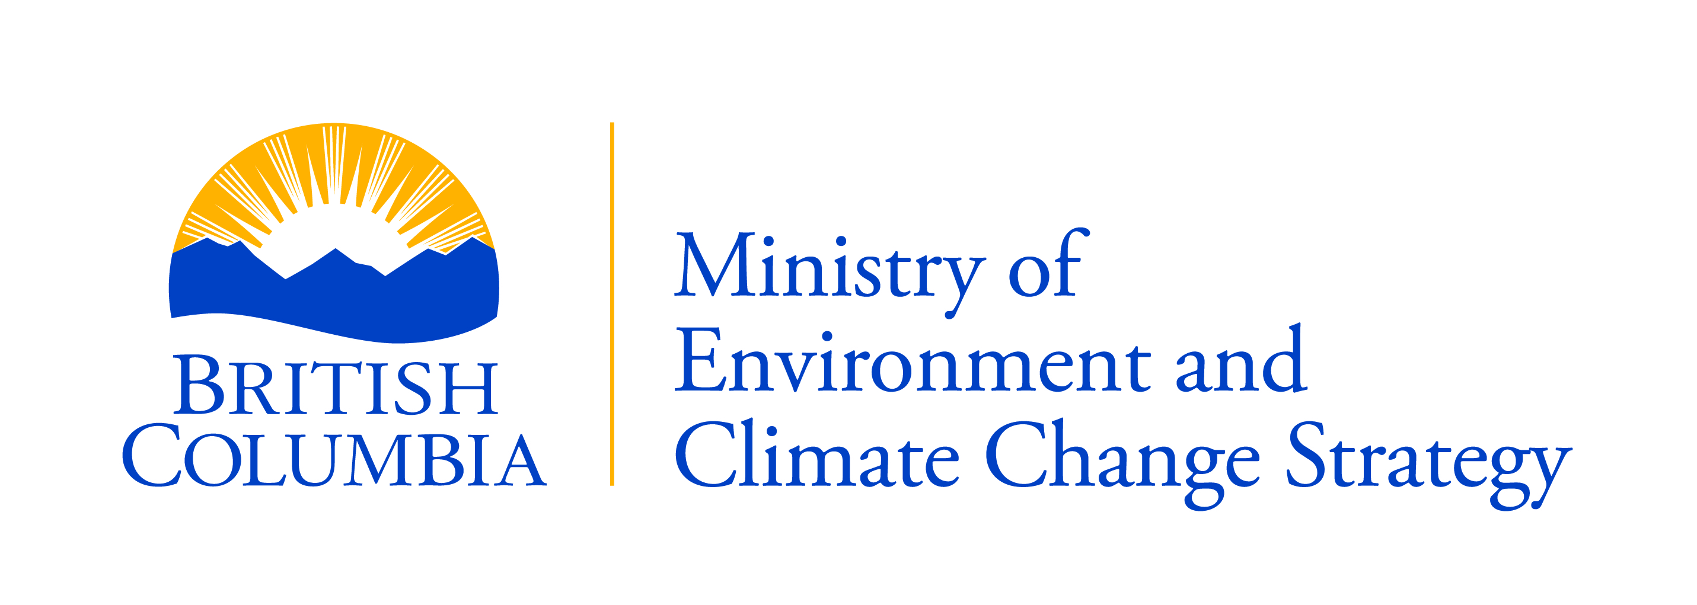 | MINISTRY OF ENVIRONMENT  BC Parks  TATSHENSHINI-ALSEK PARK  COMMERCIAL RAFTING REPORT

COMPANY NAME: PERMIT NUMBER:
YEAR:

Peak season take-out dates (July 6 to August 30)
PUT IN DATE: | TAKE OUT  DATE: | NUMBER OF DAYS IN TATSHENSHINI-ALSEK PARK: | TAKE OUT: (TURNBACK CANYON OR DRY BAY) | # OF CLIENTS: | # OF GUIDES:

Shoulder season take-out dates (all other dates)
PUT IN DATE: | TAKE OUT  DATE: | NUMBER OF DAYS IN TATSHENSHINI-ALSEK PARK: | TAKE OUT: (TURNBACK CANYON OR DRY BAY) | # OF CLIENTS: | # OF GUIDES:

